Spain

Geography

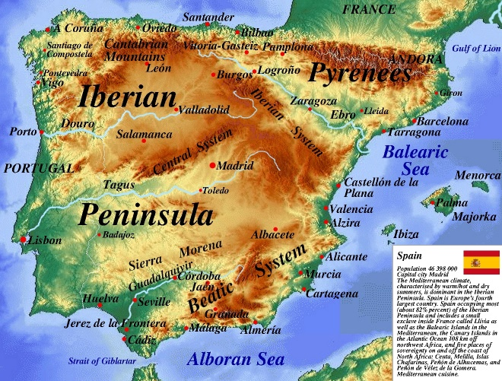Spain is a country with a diversity of geographical monuments. From its castles, its snow-covered mountains and to its lively cities. Spain provides a diversity of different things to do that will satisfy even the pickiest of tourists.

1(physicalmap.org, 2019)

* Spain is in the extreme southwestern tip of Europe. Just at the border of Africa.
* Spain occupies about 85% of the Iberian Peninsula with its smaller neighbor Portugal. (Rodriguez, 2022)
* As Spain is in the Mediterranean region it is a temperate climate that lends itself to hot dry summer and cool winters.
* The heartland of Spain is considered the Meseta. A plateau that houses cattle ranchers and grain fields.
* In the country’s northeast is where the valley of the Ebro River lies.
* Right above the valley is the mountainous region of Catalonia.
* The hilly plain of Valencia right below it.
* The northwest has the Cantabrian Mountains, quite rugged and heavily forested separated by its all peaks.
* In the south is where the citrus orchards and the valley of the Guadalquivir River lie.
* Over the valley the snow-capped Sierra Nevada, A popular local skiing range.
* The south of the country is a desert lined with palm trees and other tropical vegetation. (Rodriguez, 2022)
* A picture containing mountain, nature, sky, outdoor

  Description automatically generatedSpain also has a group islands classified as the *Balearic* Islands which consist of the Canary Islands and Ibiza. These islands attract millions of tourists every year.

22(Encyclopedia Britannica, 2022)

History

* Spain is very influential country in terms of its historical/social/artistic impact on the world.
* It is estimated about 1.2 million years ago the first settlers in Spain arrived in the Iberian Peninsula
* Spanish history is filled with different owners taking and shaping the country from the Visigoths, Christians, Muslims, The English, and the French. Spain has had its fair share of rulers.
* The Romans arrived in Spain in 200BC and occupied it for over 600 years but took them at least 200 years to defeat the toughest tribes. (Fiestas, n.d.) (Karacs, 2021)
  + 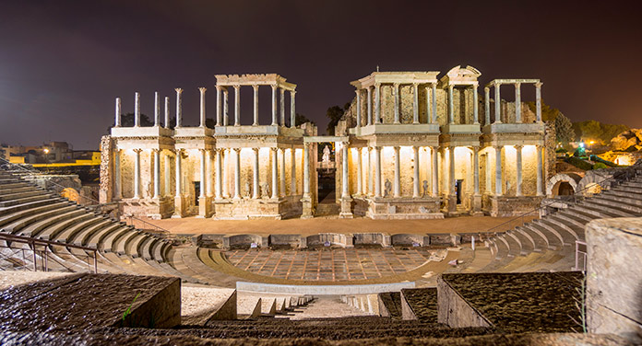The Romans are to be accredited with most of the preserved architecture that remains here today. From the road system, aqueducts, theatres and even the basis of our common knowledge is all thanks to the Romans!

3(Senator Hotels, 2019)

* The Romans rule faded, and the Germanic tribes started to take foot in the country. By 410AD they had established a majority control (Fiestas, n.d.)
* In 711AD the Moors invaded the country through north Africa. And exercised their influence by renaming the region Al-Andalus
* In the year 1492, An Italian explorer “Christopher Columbus” discovered a new route to the *New World*. Funded by Queen Isabella the first.
* Map

  Description automatically generatedThis discovery kickstarted European interest into the new world. The Spanish empire is considered one of the greatest in this era solely due to the vast influence they brought. They conquered:

4(Wikipedia,2022)

* + Vast Majority of South America
  + The Caribbean
  + Mexico
  + Large Majority of the United States
* 1936-1939 Is when the Spanish civil war took place. Fascist General Franco would defeat the republicans. (Fiestas, n.d.)
* 1936-1975 Francos death allows Spain to convert to a monarchy from its bloody fascist rule.
* 1979 - With the monarchy a path to democracy is paved and established

Government and Politics

* Spain is a constitutional monarchy. Which means the ruling monarchs act as a *ceremonial head* of state. (Rodriguez, 2022)
* Whereas the democratically elected Prime Minister acts as the head of the national government.
* The current government system has been in place ever since the great transition the period of time when the fascist leader Francisco Franco took power to the monarchs in 1978, The constitution allowed for a more democratic Spain
* Spain has 3 Distinct branches of government (Karacs, 2021):
  + Executive
    - Responsible for leading the national government. This branch includes the deputy prime ministers and other ministers
  + Legislative
    - Comprises of two chambers: Directly elected lower house and the Congreso de los Diputados (Congress of Deputies) and the upper house Senado (Senate)
  + Judicial
    - Spains judges and magistrates make up this branch. They are independent and subject only to the law.
* Some of Spain’s Political Parties in Spain Include:
  + 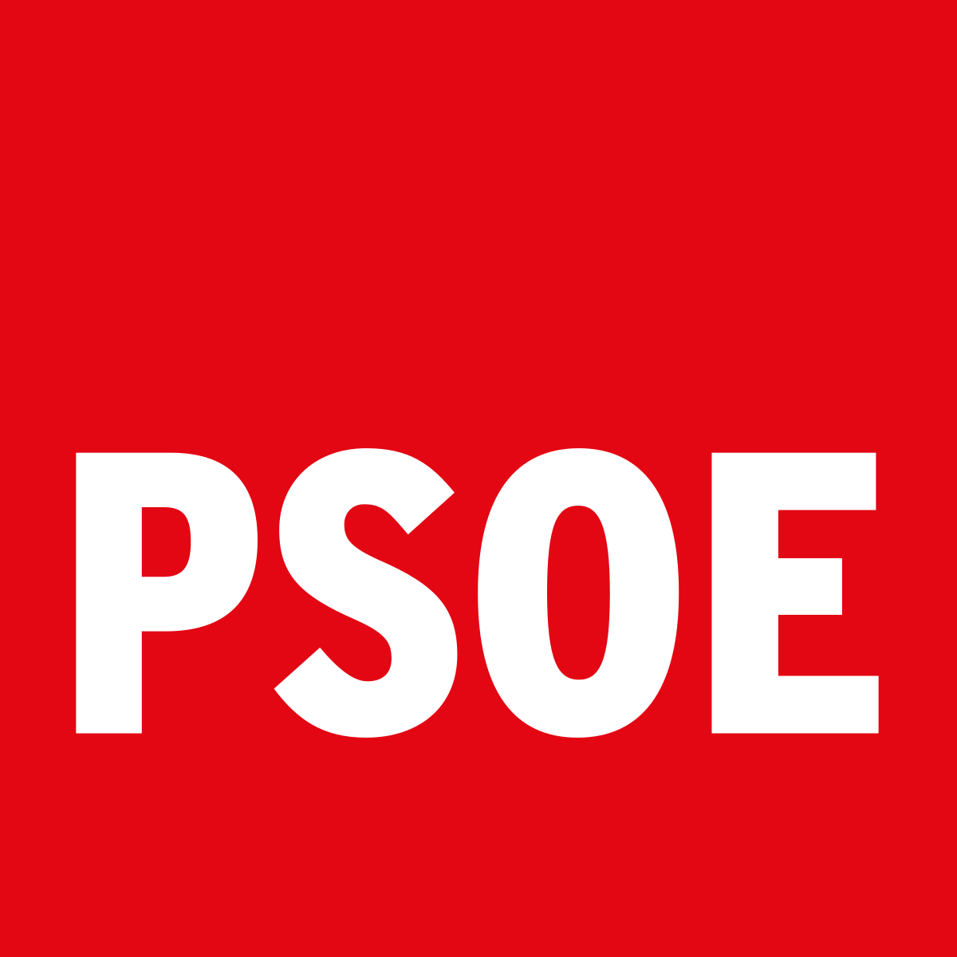**Partido Socialista Obrero Español (PSOE) – The socialist party of Spain, Oldest party in Spain. It has been in power longer than any other party in democratic Spain. They have a progressive ideology. Iglesias Posse a union organizer founded the party with its current leader being Pedro Sanchez**
  + **Partido Popular (PP) – Popular Party are a liberal-** **conservative party with a Christian-democratic ideology. The party was last in power in 2018**
  + **Unidas Podemos (UP) – An alliance of smaller progressive parties this part was a runner up in the 2016 general election.**
  + Logo

    Description automatically generated**Ciudadanos – “Citizens” when translated. This party is quite extreme with being a liberal-conservative, pro-European.** (Karacs, 2021)
  + **Vox – Founded by the former members of the popular party. Their ideals lie in anti-immigration and are considered to be a nationalist party.**
* Map

  Description automatically generated**Spain is comprised of 17 autonomous regions which are separated into 50 provinces.** (Rodriguez, 2022)

5(6Emilio Gómez Fernández & Javi C. S.,2010

)

* **Spain’s capital city is Madrid. It is also considered to be the country’s arts and financial centre.**
* Famous Spanish Leaders:
  + Philip II: King of Spain (1556-1598), Became king of England and Ireland and attempted to overthrow Elizabeth the first. (TheFamousPeople, n.d.)
  + Hernan Cortes: Conquered the Aztec Empire and the majority of Mexico.
  + Francisco Franco: Fascist Leader who overthrew Second Spanish Republic. Was a dictator
  + Francis Xavier: Famous Catholic missionary who preached from South Asia to East Asia (TheFamousPeople, n.d.)

Economy

* Spain has a mixed capitalistic economy.
* Considered to be the 39th freest economy. (Freedom, 2022)
* Spain is ranked #24 out of 45 in the European region in terms of government integrity (Rodriguez, 2022)
* Since its return to democracy. Spain has become Europe’s 5th largest economy with it being the 14th biggest largest in terms of nominal GDP. (Freedom, 2022)
* Spain has a diverse economy with the majority of their GDP being contributed by its:
  + Manufacturing industry
  + Financial Services
  + Pharmaceuticals
  + Apparel
* Spain’s largest city is by far its capital, Madrid. The center of the national government, transportation hub of the country and the home to the famous football club Real Madrid
* Barcelona is a close second with a very large industrial region (Harrison, 2022)

Famous People

Spain has an abundance of people who have had a large impact on their world some of which are:

* Pablo Picasso – The infamous 20th century artist who is best known for his works such as “Gurenica” and “Les Demoiselles d’Avignon”
* Rafael Nadal – Considered to be one of the best tennis players of all time
* 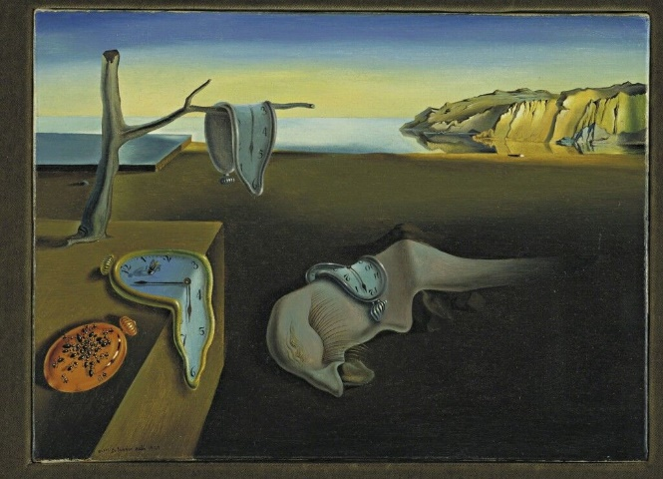Penelope Cruz – The Spanish actress best known for her roles in “Vanilla Sky” and “The Pirates of the Caribbean franchise”
* Salvador Dali – Yet another famous artist. He is best known for his bizarre style of paintings.
* Kane – One of the most well-known WWE© wrestlers. (Birthday?, n.d.)

Figure 1(The Museum of Modern Art)

Demographics

* Population of Spain is around 47.3m people. It is the 5th most populous European country.
* European Spanish is the main language of Spain
* The national sport of Spain is football.
* One of the most famous symbols of Spain must be the Spanish bull, Bullfighting gets its origin from Roman arena games.
* Religion in Spain

|  |  |  |
| --- | --- | --- |
| Rank | Religion | Percentage of Pop |
| 1 | Roman Catholic | 67.4 |
| 2 | Non-Religious | 15.6 |
| 3 | Atheist | 12.2 |
| 4 | Islam | 4 |
| 5 | Other Religions | 0.08 |
| Total | 100% | |
| Table Data Acquired From: (Pariona, 2014) | | |

Fun Things To Do

* Suggestions to do while in Spain:
  + Visit the Balearic Islands
    - Some of the most beautiful places to visit on Earth!
    - The islands are one of the best places to relax in Europe!
    - The islands include the infamous *Ibiza* Island the hub for its lively nightlife and is considered the worlds clubbing
  + Visit the Church of the Sacred Family**©**
    - One of the longest ongoing projects
    - This church has been under construction since 1882. Designed by Antoni Gaudi who is most known for his intricate structures that dot Barcelona.
  + Attend a Flamenco show
    - Flamenco features the song, dance and guitar music that has developed over the years from the songs of the Roma people.

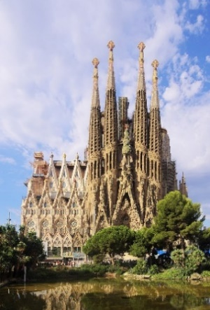

7(C Messier,2017)

# Works Cited

Birthday?, C. B. (n.d.). *Famous People of Spain*. Retrieved from https://www.thefamouspeople.com/spain.php

Fiestas, S. (n.d.). *History of Spain*. Retrieved from Spanish Fiestas: https://www.spanish-fiestas.com/history/

Freedom, I. o. (2022). *Spain*. Retrieved from Index of Economic Freedom: https://www.heritage.org/index/country/spain

Harrison, R. J. (2022, Feb 13). *Spain*. Retrieved from Brittanica: https://www.britannica.com/place/Spain#ref70257

Karacs, S. (2021, October 1). *The government and political system in Spain*. Retrieved from Expatica: https://www.expatica.com/es/living/gov-law-admin/spain-government-106928/

Pariona, A. (2014, June 14). *The Major Religions In Spain*. Retrieved from World Atlas: https://www.worldatlas.com/articles/religion-in-spain.html

Rodriguez, V. (2022, February 13). *Spain*. Retrieved from Encyclopædia Britannica: https://www.britannica.com/place/Spain

TheFamousPeople. (n.d.). *Famous Spanish Leaders*. Retrieved from Celebrities Born On My Birthday?: https://www.thefamouspeople.com/spanish-leaders.php